Shitot software requirements

1. Migrating DB from excel to a cloud DB.
2. Creating an easy to use web based UI to manage DB including reports generator.
3. Creating phone app for end users.

Scenario 1:

A client calls and is referred to one of the therapist in shitot org -> the client info is added to DB via web UI -> the app user (therapist) receive a message that a referral was made + basic info (name and tel).

Scenario 2:

Therapist updates referral status

Enters app -> search referral by name or between dates -> update to status 'client started therapy'.

Scenario 3:

Therapist updates available hours

Enters app -> press 'my available hours' -> adds day and time which is avail

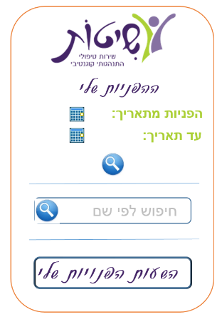App Screens:

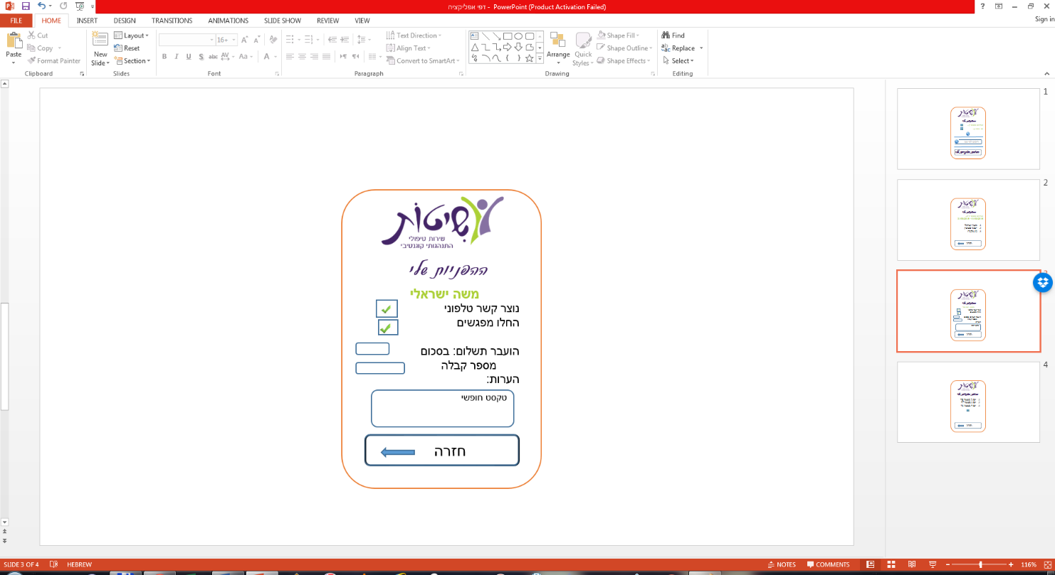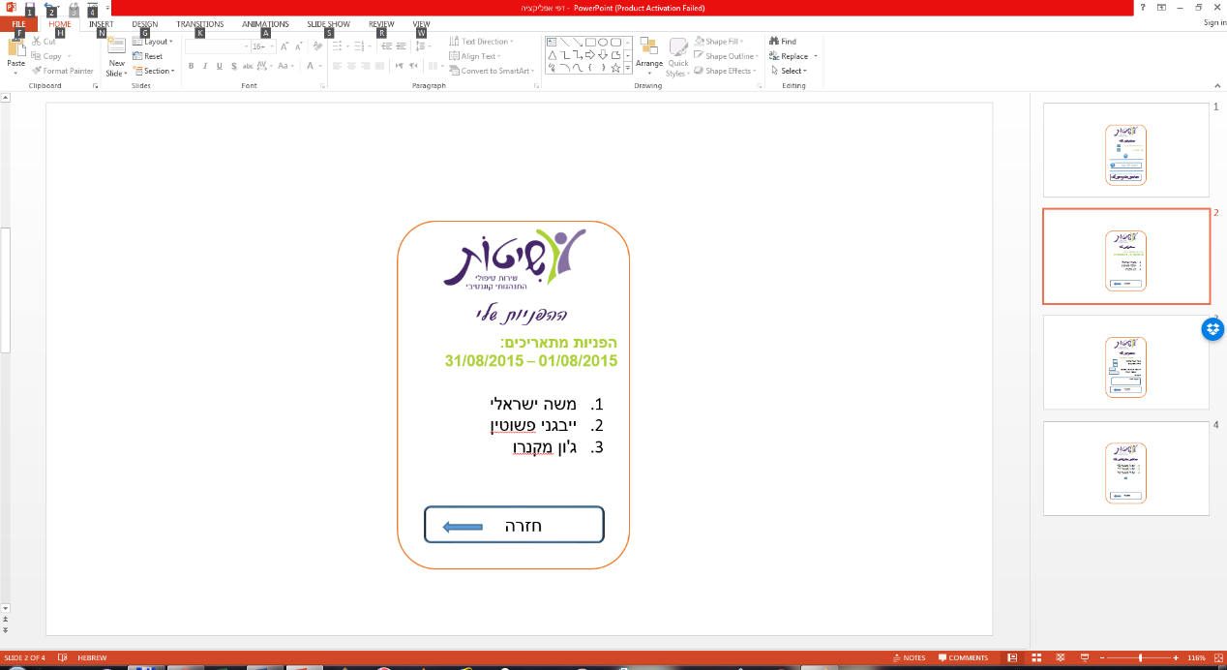

-🡪 🡪 🡪

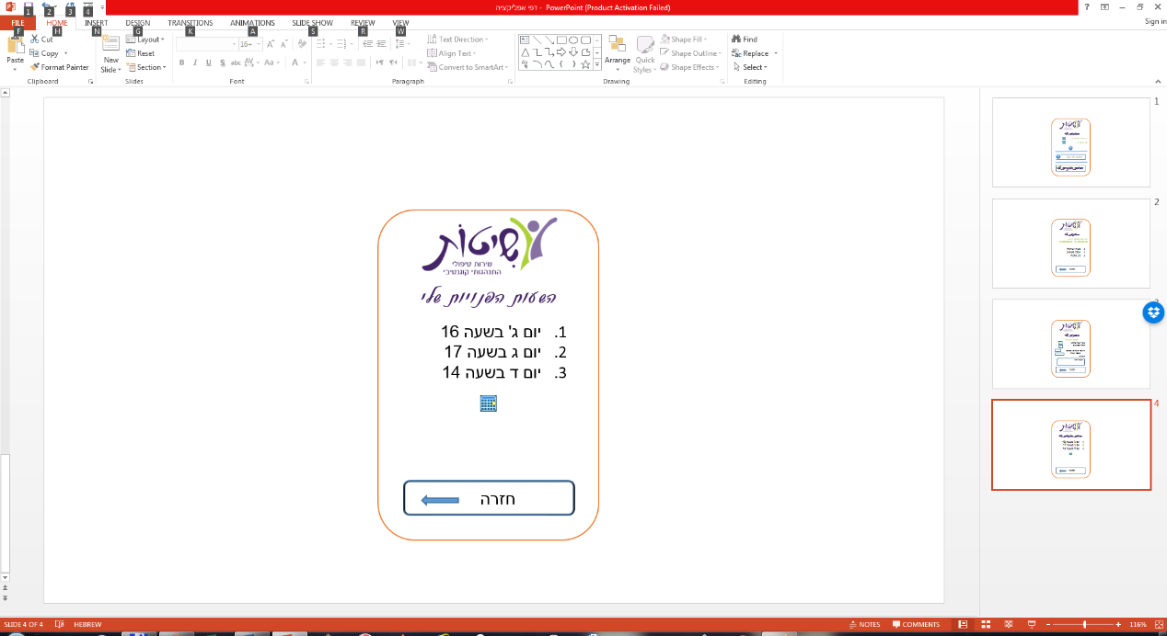

Reports:

1. Therpist personal info
2. All refferals per therapist
3. All referrals per therapist that have not been paid
4. All referals that were not paid
5. Sum of paid referall per year/month
6. Statistics of symptoms
7. Refferals that called but therapy was not realized
8. Refferalls per dates – how many, how many called, how many started therapy, how many were paid for.

**Storage**

Must be super secure!!!

**DB add a few more columns:**

**Referrals**

1. טלפון פונה
2. הפרעות 1-5 עמודות
3. יישוב
4. טקסט חופשי בזמן הוספת הפניה
5. טקסט חופשי של מטפל המדווח דרך האפליקציה

**Therapist**

1. שם
2. כתובת קליניקה 1
3. כתובת קליניקה 2
4. טלפון
5. ימים ושעות פנויות
6. מקצוע
7. התמחות